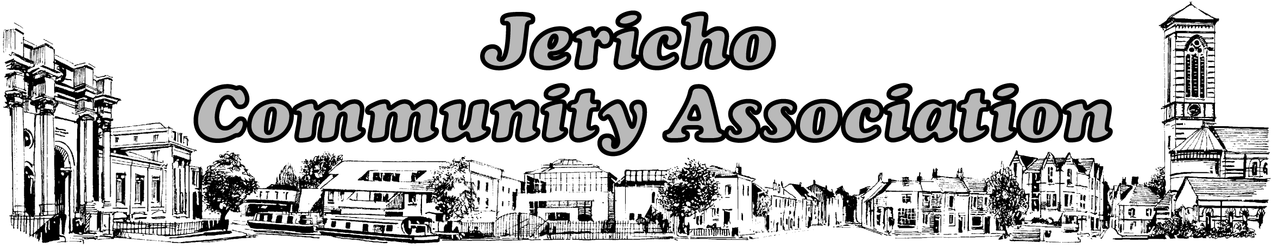
Registered Charity No. 1168203
Jericho Community Centre, 33a Canal Street, Oxford OX2 6BQ
Tel: 01865 557902 – admin@jerichocentre.org.uk – www.jerichocentre.org.uk

Jericho Street Fair
Saturday 10th June 2017 @ 12 noon
Stall Booking Form

We offer a half stall for those who are non-profit making or individuals and full stall to profit making groups. The same organisation/person cannot book 2 half stalls
If you wish to share a stall with another specific person please state this clearly on the form and submit both forms and payments at the same time. Otherwise half stalls will be allocated by the JCA. We cannot meet preferences made on the day.

Please book No later than Wednesday 31st May 2017. No bookings are accepted after this date. You can:
- Print and return this form with a cheque payable to Jericho Community Association mailed or delivered to the community centre at the above address. or,
- Return the completed form attached as an email to admin@jerichocentre.org.uk and pay by bank transfer to our account 08-92-99 65815984. Please use Ref: SF17

I am / we are a non-profit-making individual / group and enclose £5 payment for a half a stall.
I am / we are a profit-making individual / group and enclose £25 payment for a full stall.

I / We enclose the fee of £………... cheque for Jericho Community Association.
Or, have transferred £………… to account 08-92-99 65815984. Ref: SF17

Organisation……………………………………………

Contact Name: …………………………………………

Email Address: …………………………………..Telephone Number: …………………………

Address: ……………………………………………………………………………………………..

Brief details of Stall: ………………………………………………………………………………..

Food providers:
Please confirm that you have a food hygiene certificate. You will be required to present this on the day if requested.

